**WE’RE GETTING MARRIED!!!!!**

Date: Jan 2, 2016

Ceremony Locations:

* + **Trinity UMC -** 
    - <http://trinitynewalbany.org/>
    - $1050 for ceremony
    - $1300 for ceremony/reception
    - Includes minister/organist –ask about reception music
    - $200 deposit
    - No alcohol on premesis!
    - 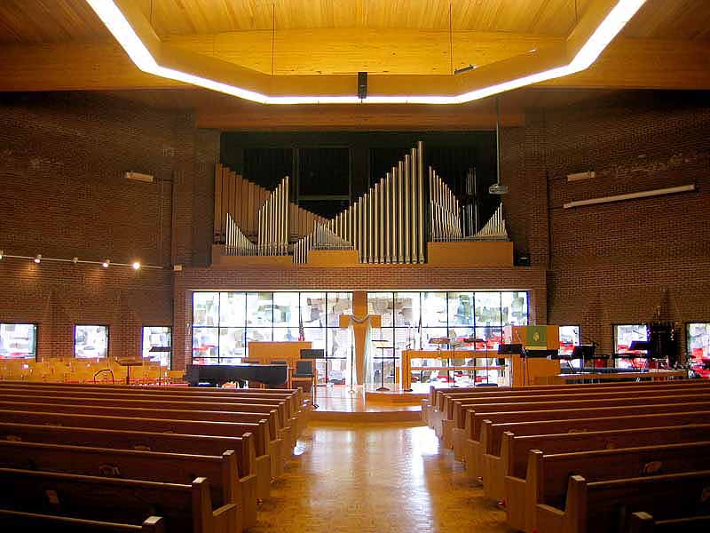
  + **St. Matthews BC** 
    - <http://smbclouisville.org/>
    - Closes @ 4 on Sat’s. – custodial clean-up after 4 costs $37.50/hr
    - Must be afternoon wedding, morning wedding if reception is there
    - Closed 1/1, rehearsal must be 12/31.
    - $1150 for ceremony, not including minister or musicians
    - $2500 for ceremony/reception
    - $50 deposit
    - 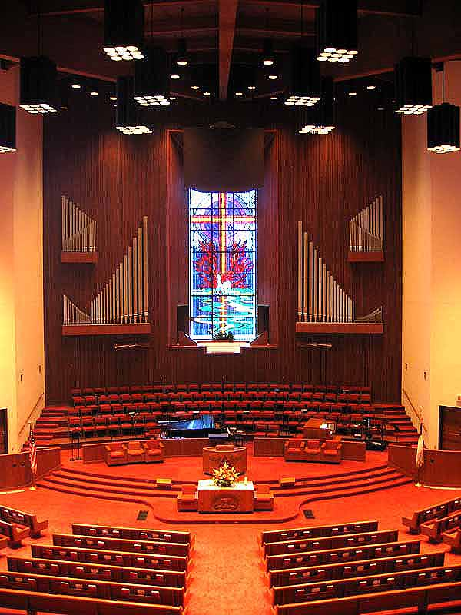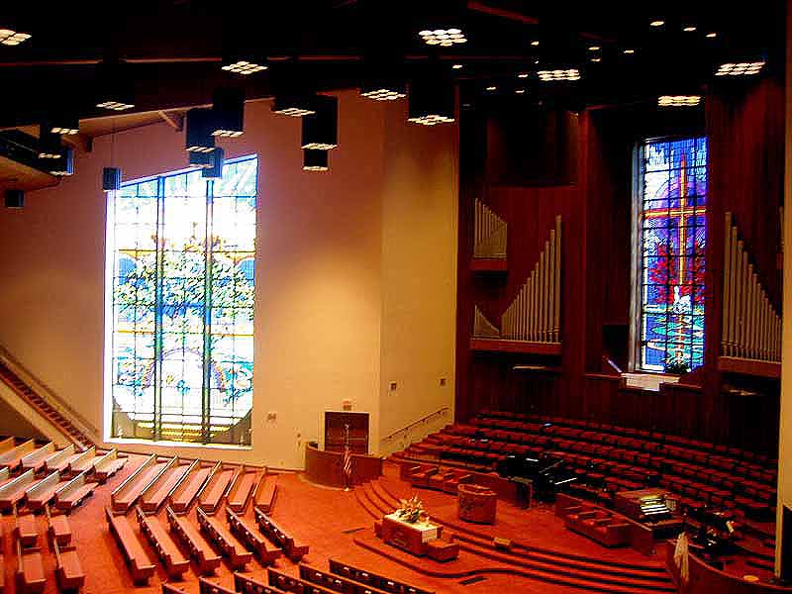
* **Charlestown Road Church of Christ (emailed)**
  + <http://www.charlestownroadchurchofchrist.com/>
* **Sellersburg UMC (emailed)**
  + <http://www.sellersburgumc.com/>
  + 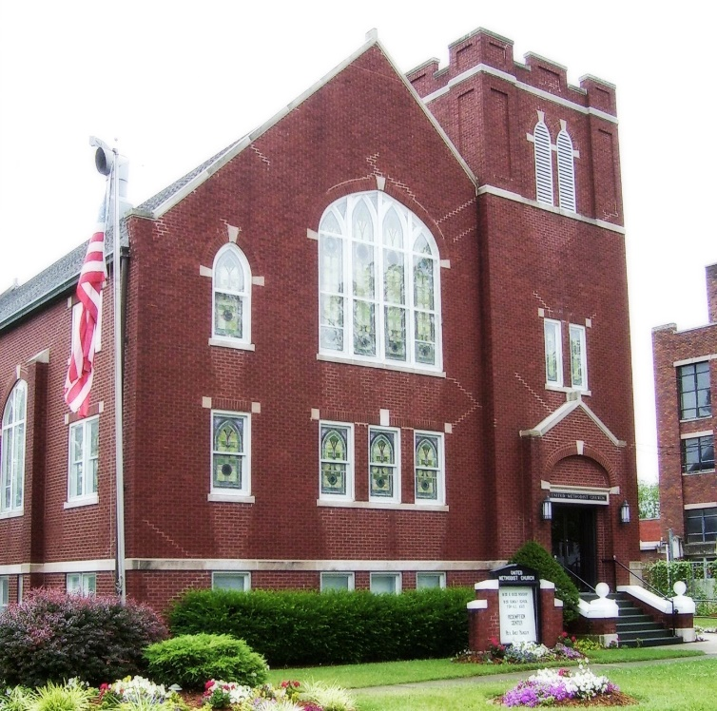
* **Graceland BC (emailed)**
  + <http://gracelandbaptist.org/>
  + **St. Paul UMC (info online)**
    - <http://www.stpaulchurch.net/Weddings.html>
    - $500 deposit, $1500 total for ceremony
    - Minister included
    - 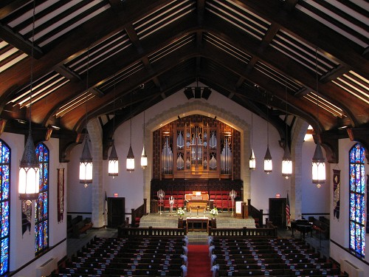
  + **Highland BC (info online)**
    - <https://hbclouisville.org/about-us/weddings/weddingapplicationandpolicies/>
    - $200 Deposit, $1275 total for ceremony
    - $775 reception, $2050 total
    - Does not include minister/musicians
    - 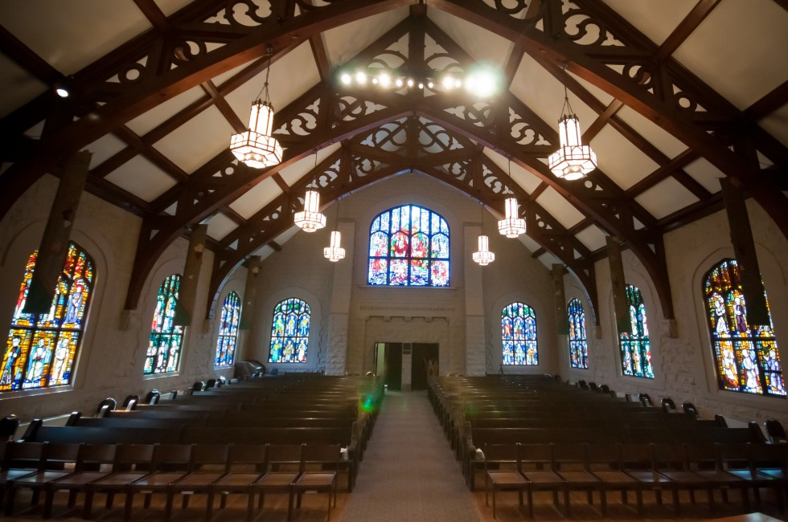
    - 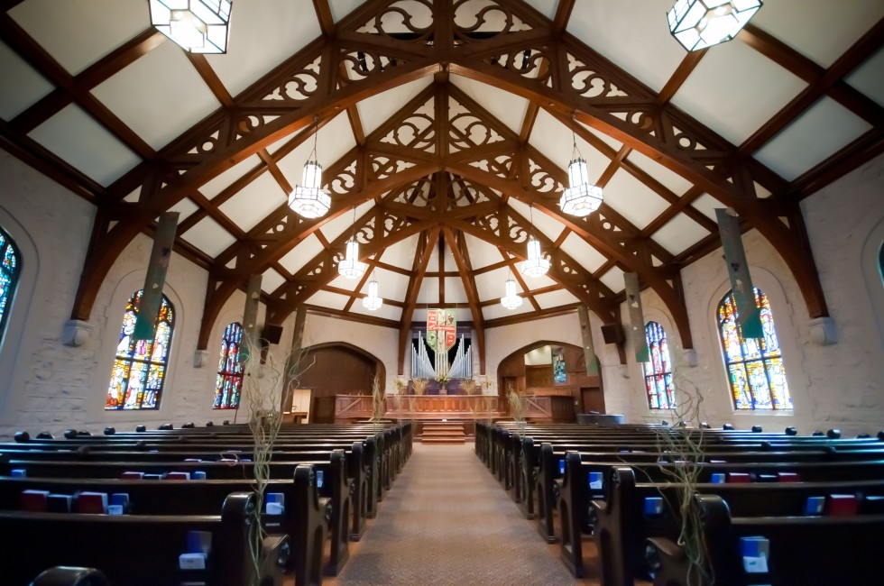
  + **St. John UCC (info online)**
    - <http://www.saintjohnucc.com/weddings.html>
    - $500 deposit, $1600 total ceremony
    - 
     